Wiring Overview

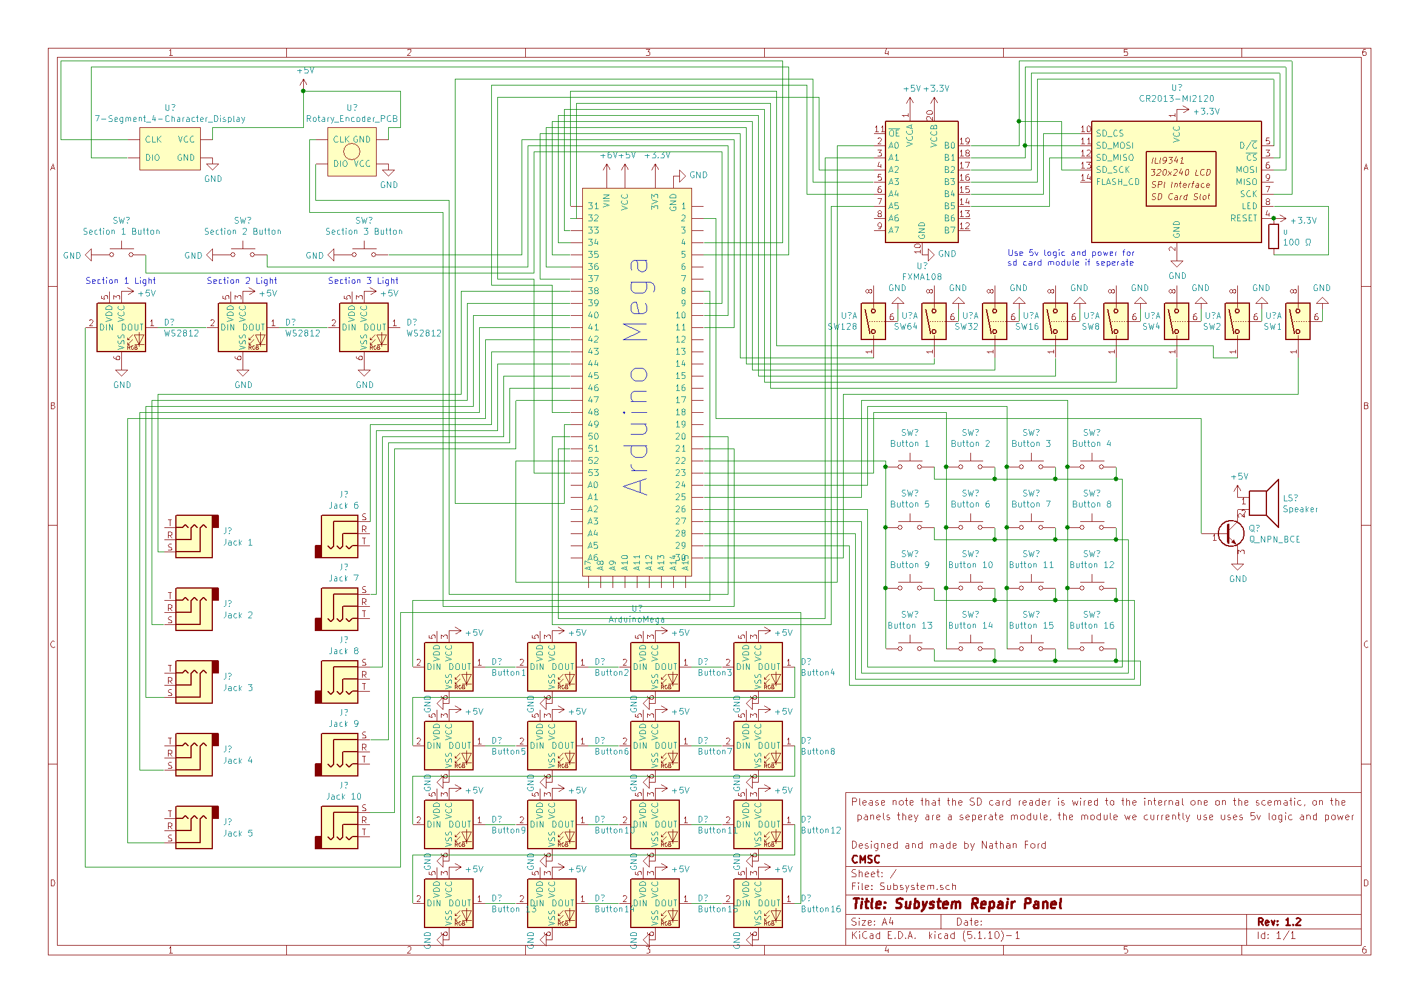 So, you have come to learn more about the wiring, eh? The schematic will give you most of the information you need, but if you want a wordier explanation, you have come to the right place. I will divide this into 4 parts, the wiring for the first section, the wiring for the second section, the wiring for the third section, and the wiring for the screen, speaker, and section buttons.

Part 1

First off, we have our Rotary encoder, Our clock (CLK) and data (DIO) pins on our rotary encoder will go to pins 20 and 21, these pins are selected because they are both interrupt pins on the arduino mega, and rotary encoders are a lot more stable if you put them on interrupt pins, also it does not matter the order, if the rotary encoder is shifting numbers backwards, simply flip the pins. Next, we have our Seven segment display, this one does matter which pin is clock and data, clock will go to pin 4 and data will go to pin 5.



Next, are our binary switches, these are what select what puzzle we are going to do. The switches that subsystem were designed for are SPST toggle switches with lights, sadly, at the time of making these panels, the only toggle switches with lights in the style we wanted are rated for 110VAC so the lights don’t light up, if you are able to find some that do light up, all you would do is wire the light up to 5VDC. The signal of these switches go to pins 30-37, 30 for the 1 bit and 37 for the 128 bit.

Part 2



Section 2 is our jack section, for these we used stereo guitar pedal cables, because they are large, and relatively robust. It should not matter what pin on the jack you decide to attach to, if you are consistent, and it is not the jack detect pin. That noted, we decided to on the first batch of panels to put them all on the pin that attaches to the tip of the cable, so we can use mono cables which are cheaper, and it does not short out with the metal chassis of the panel. These jacks are wired to pins 38-47 on the Arduino mega.

Part 3



This section is arguably the hardest section to wire, to reduce the pins used I decided to go with a grid type layout, like a capacitive touch display sort of. The Arduino will rotate setting one of the columns to a LOW state and then check each row to see if one of the pins (with a pullup resistor) was pulled LOW as well, and if it was, then that means that button was pressed. these are wired from pins 22-29.



The WS2812 Individually addressable LED’s that help add color to this panel, these are the meat of the button section, each button has one of these inside of it, they are wired (looking from the back of the panel) left to right, top to bottom. Each of them requires 5v and GND, you wire the DOUT from one to the DIN of the next, the first one’s DIN is wired to pin 8, and the DOUT of button 16’s goes to the Section 1 check button.

Part 4



The section buttons are what the User presses to check and see if the solution they entered is correct. Section 1 is wired to pin 9, Section 2 to pin 10, and Section 3 to pin 11. Each of these buttons also has a WS2812 in it to turn green if they got it correct, red if they did it wrong, and white if it is processing. Again, they are daisy chained starting with the first one wired from the DOUT of the grid lights.



The speaker, the part of the panel that gives the user Intant gratification if they get the puzzle correct, is relitivly easy to wire, it just uses an NPN transistor connected with it’s collector to one side of the speaker, its emmiter to GND and its Base connected to pin 2 on the arduino in a simple amplification circuit. The other side of the speaker is connected to 5v.



The screen and the SD card reader, the true heroes of the subsystem panel, these are what makes the rest of the panel possible, because these are what prompts the user and where the puzzle solutions are stored. In this schematic I just grouped the sd card reader and the tft display together, because if you buy an ILI9341 controller board, you technically don’t need a second SD card reader, though with the panels I have built I did use a separate sd card reader, one that supported 5v logic and power, so you would just connect CS, MISO, MOSI, and SCK to pins 48, 52, 50, and 51 respectivly. The tft screen requires both 3v3 power and logic, or else it will be fried, so make sure that you get a bi-directional logic level converter like shown in the schematic, between the arduino and the screen. The pins on the screen should go, SCK -> Logic Converter -> pin 51, MOSI -> Logic Converter -> pin 50, Screen CS -> Logic Converter -> pin 53, Screen DC -> Logic Converter -> pin 49, VCC to 3v3, GND to GND, Reset to 3v3, LED/Backlight -> 100 Ohm resistor -> 3v3/5v.

Now, you should have the knowledge of how to wire and debug wiring on the Subystem Controll Panel!